CSE110 Quiz Section 2 WED 09/03/2011
A

ID __________________ Name in CAPITAL ______________________________________________

The factorial of a nonnegative integer n is written as n! (pronounced "n factorial") and is defined as follows:
n! = n x (n-1) x (n-2) x ….. x 1 (for values of n >=1)
and n! =1 (for n = 1)
Example; 5! = 5 x 4 x 3 x 2 x 1, which is 120. Write the flowchart of a program that reads a nonnegative integer and computes and prints its factorial.

Q2) Write the output of the following flowchart:
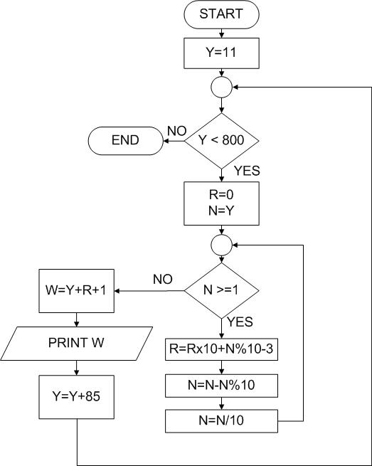
Output

